

Democracy with Adjectives: Conceptual Innovation in Comparative Research
Author(s): David Collier and Steven Levitsky
Source: World Politics, Vol. 49, No. 3 (Apr., 1997), pp. 430-451
Published by: Cambridge University Press
Stable URL: https://www.jstor.org/stable/25054009
Accessed: 28-08-2018 18:26 UTC

JSTOR is a not-for-profit service that helps scholars, researchers, and students discover, use, and build upon a wide range of content in a trusted digital archive. We use information technology and tools to increase productivity and facilitate new forms of scholarship. For more information about JSTOR, please contact support@jstor.org.

Your use of the JSTOR archive indicates your acceptance of the Terms & Conditions of Use, available at https://about.jstor.org/terms

Cambridge University Press is collaborating with JSTOR to digitize, preserve and extend access to World Politics

This content downloaded from 129.252.33.84 on Tue, 28 Aug 2018 18:26:12 UTC
All use subject to https://about.jstor.org/terms

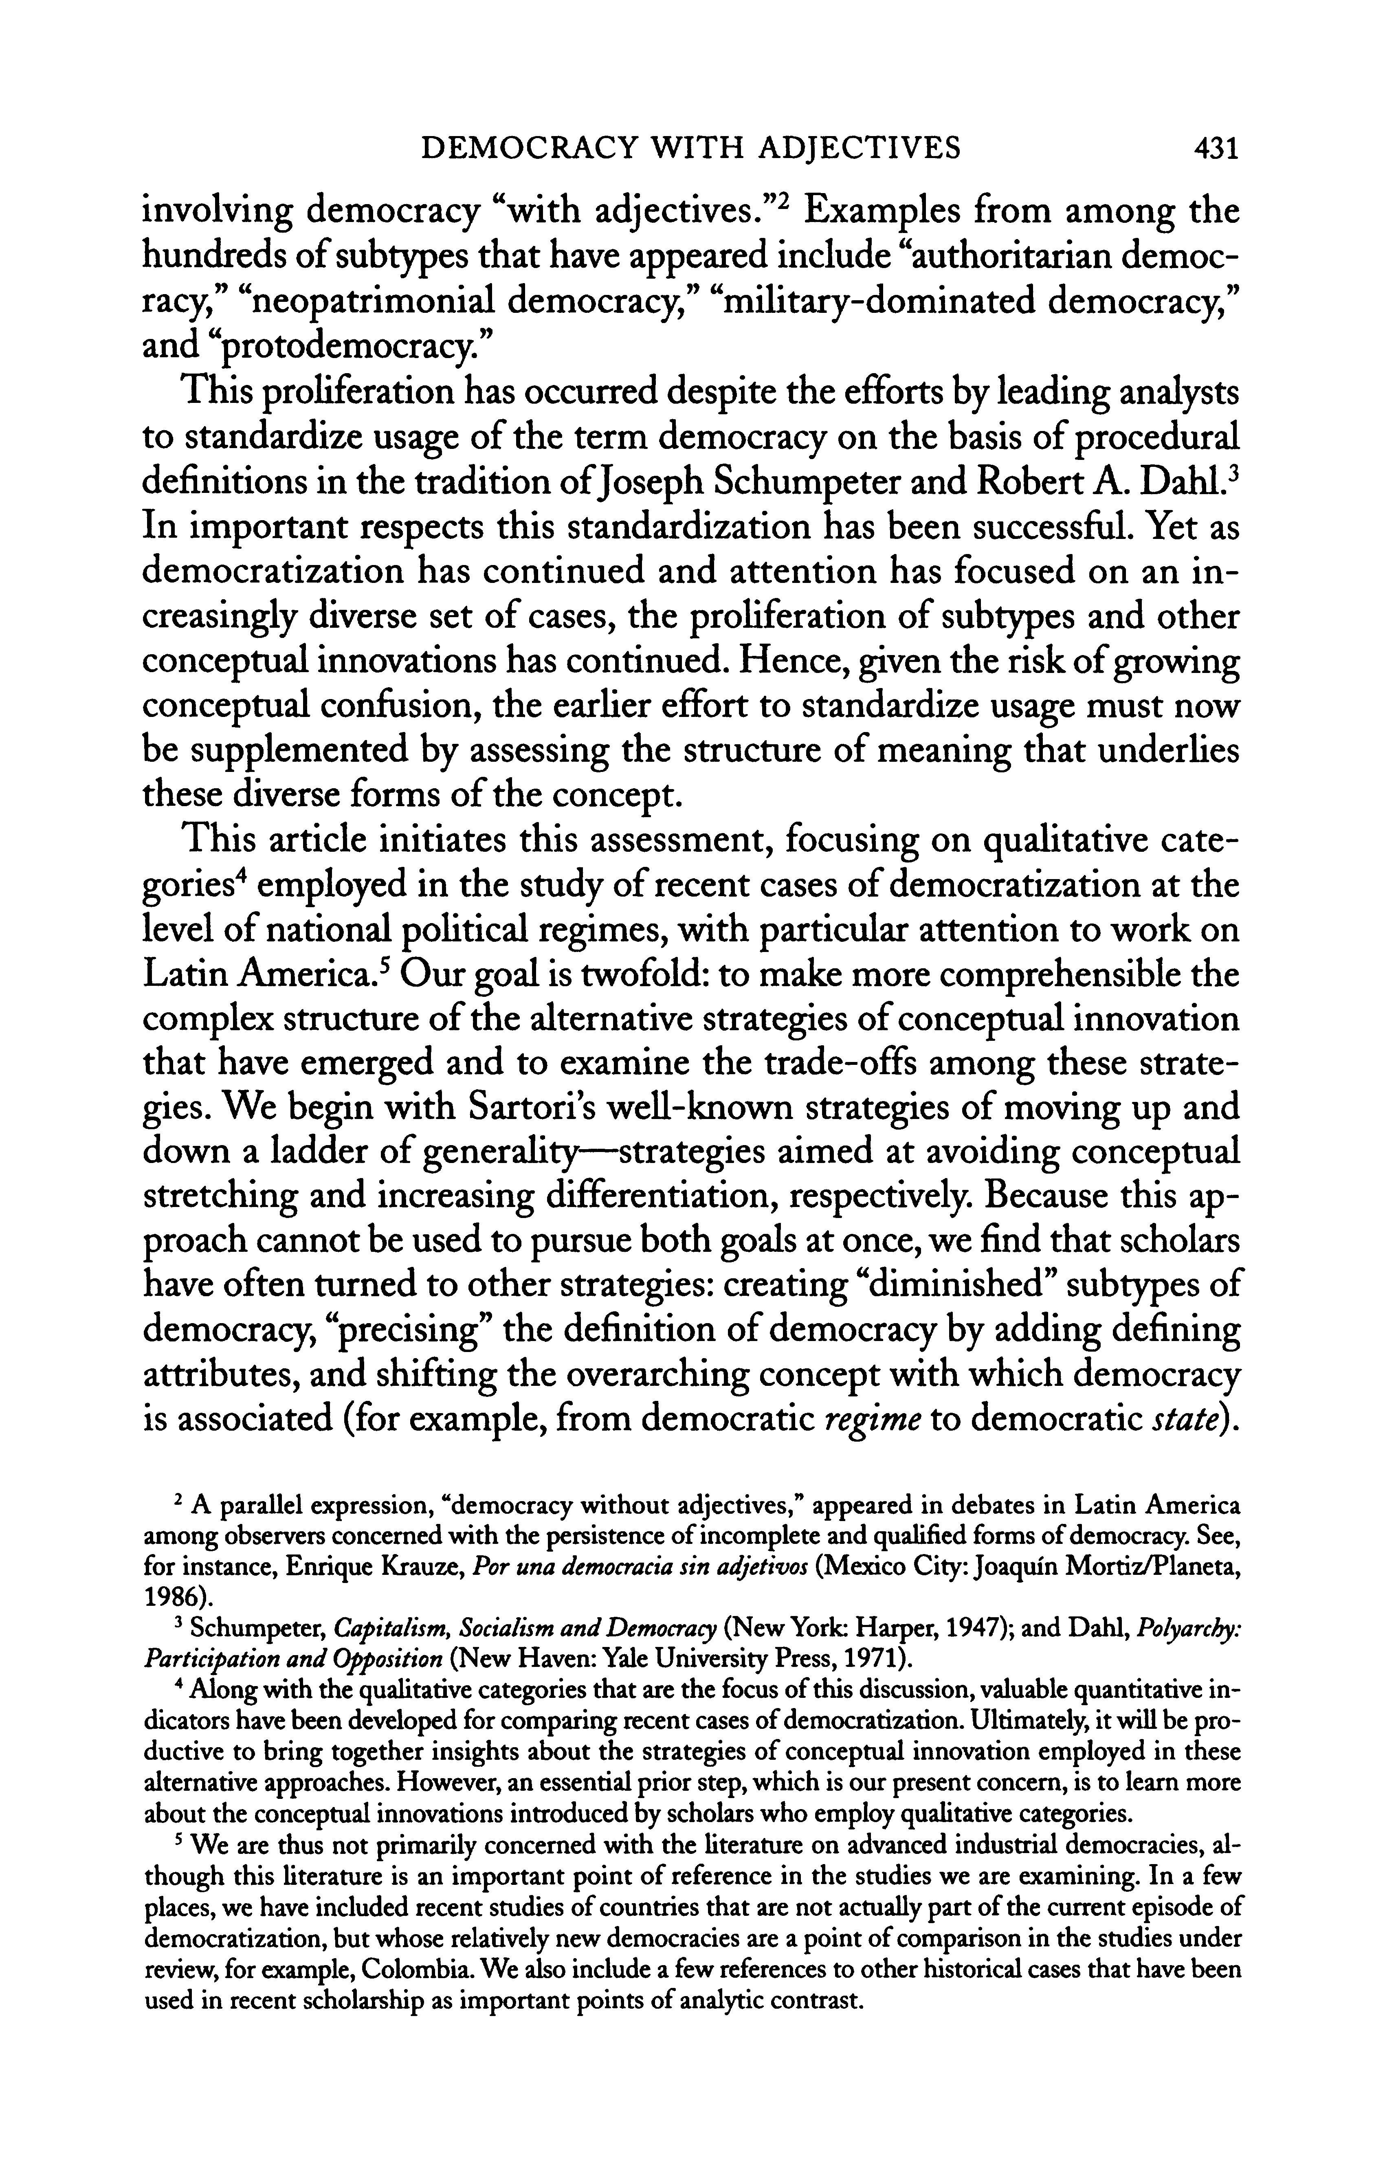
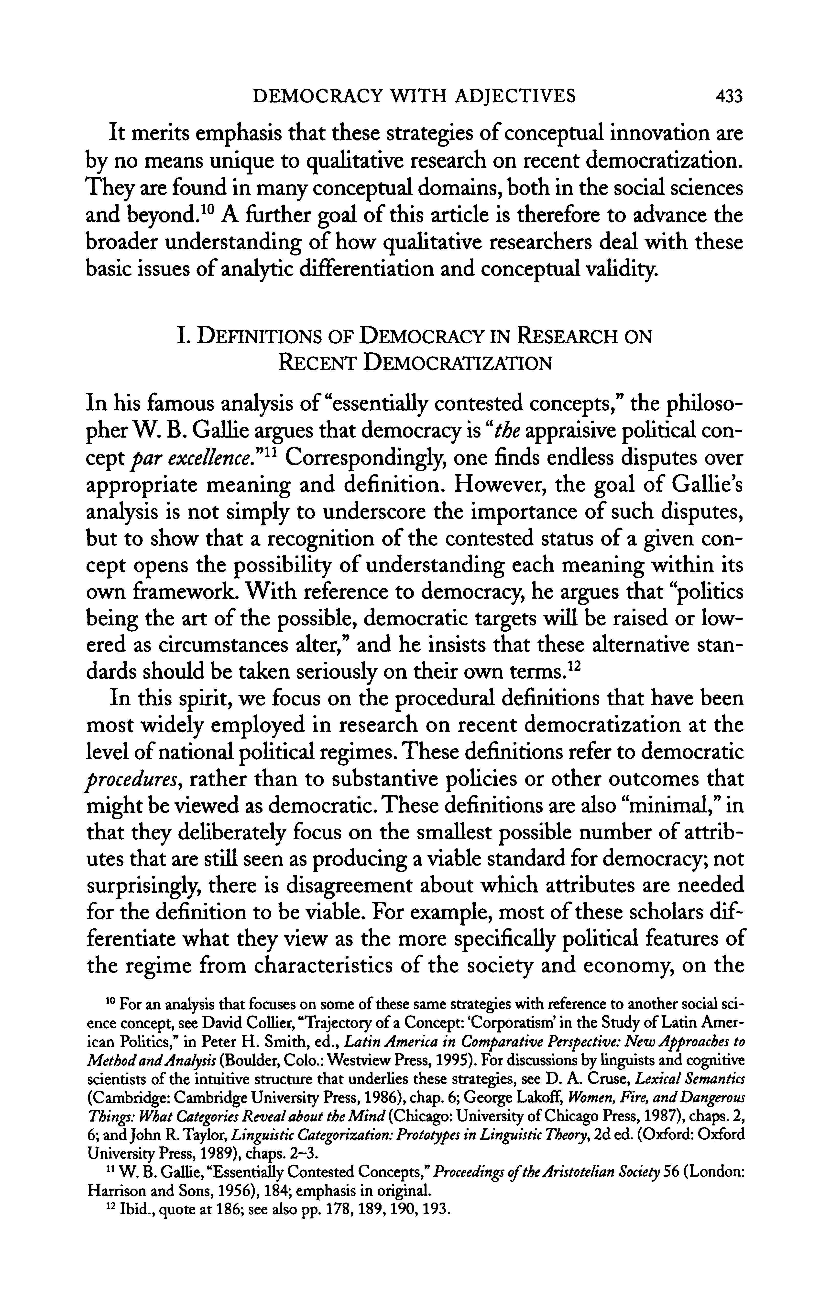
436

REGIME

I

i
I
DEMOCRACY

"

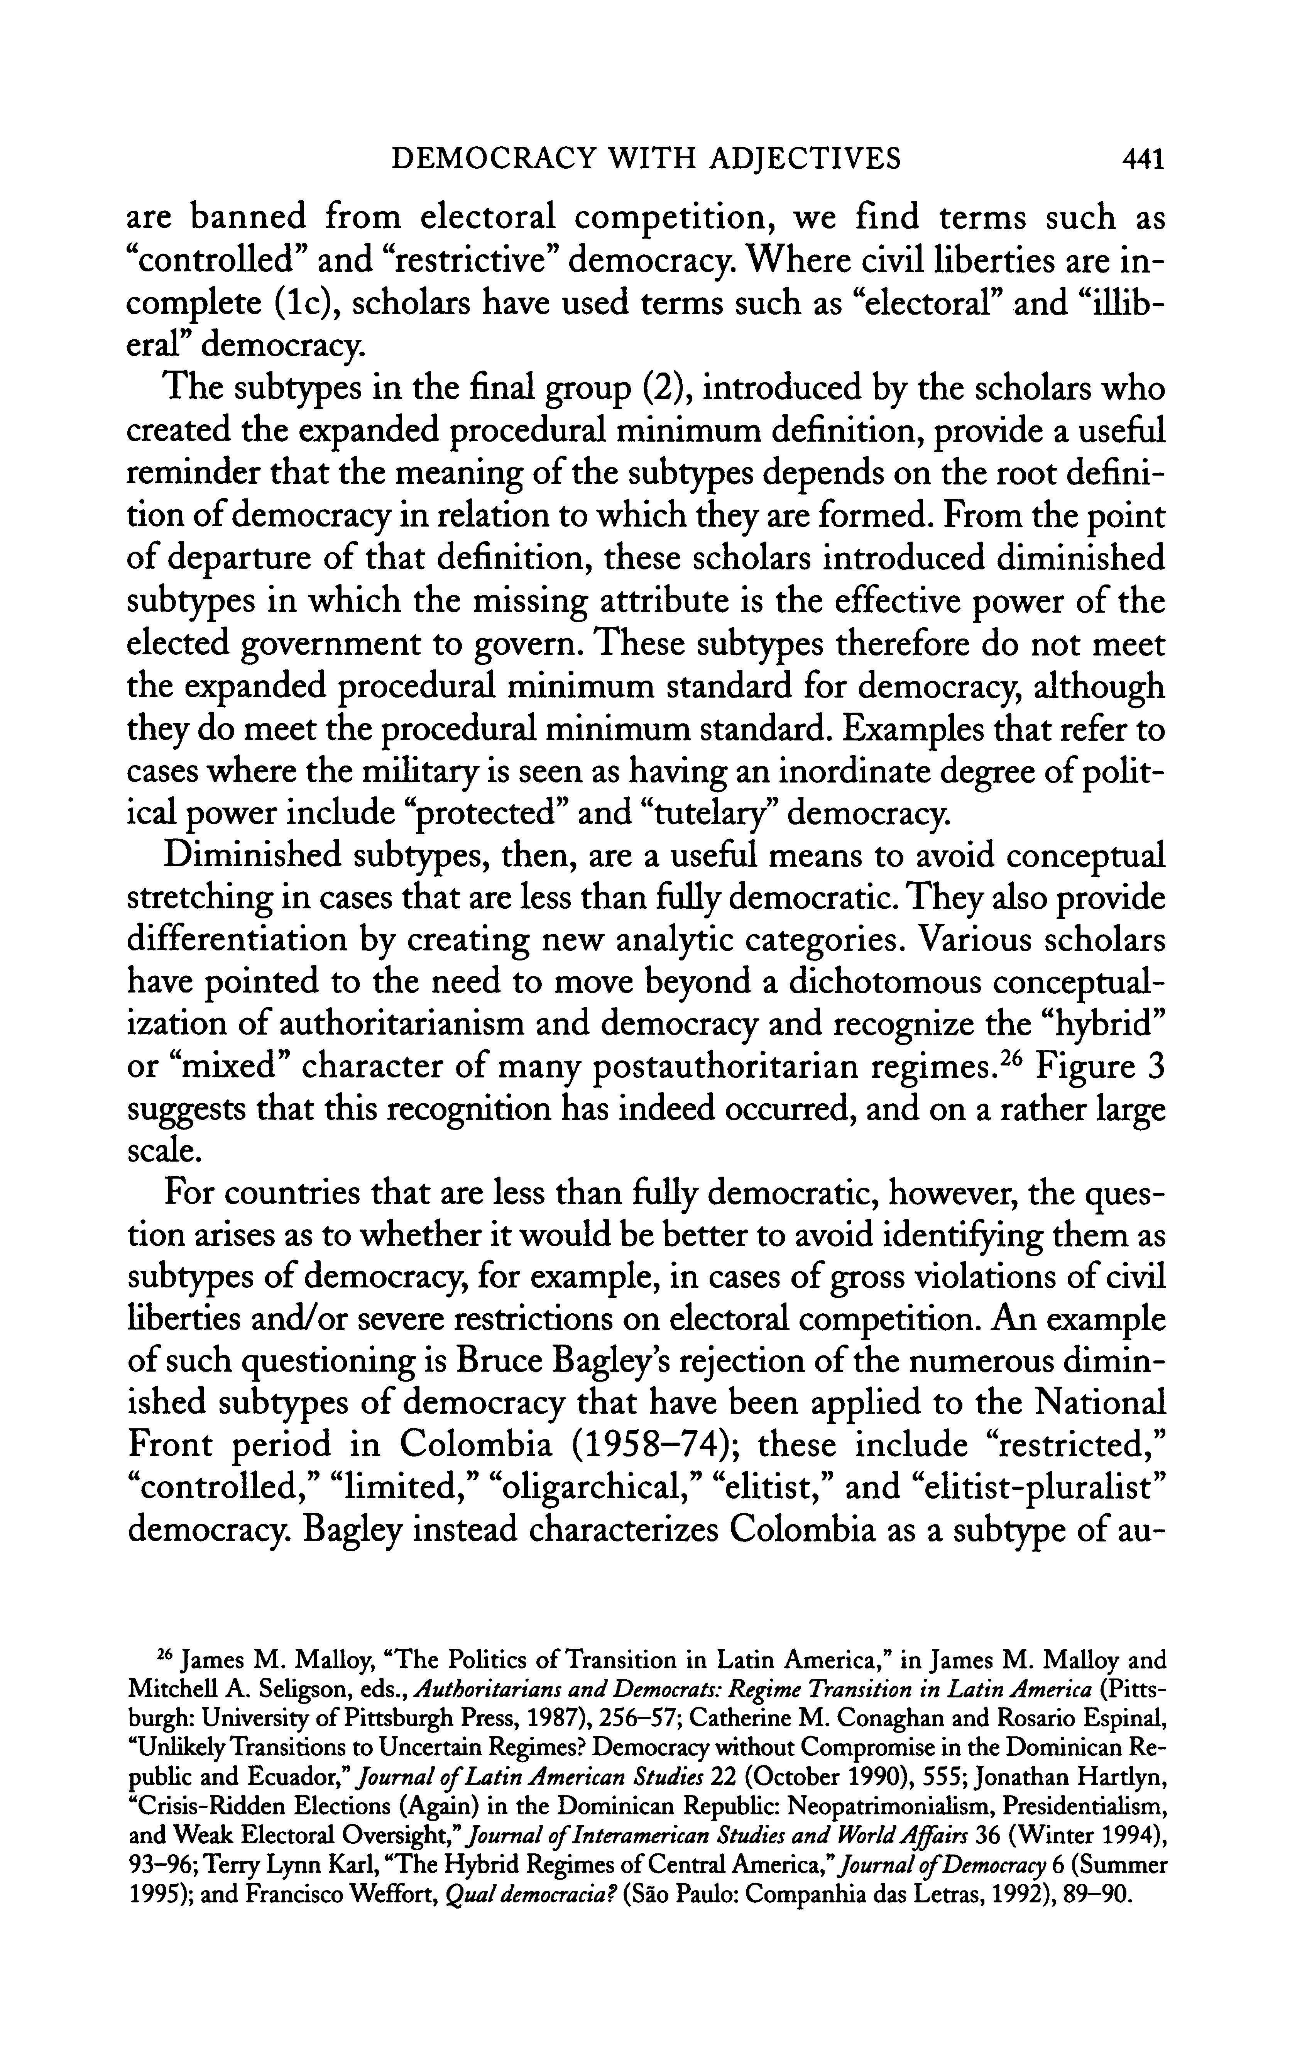
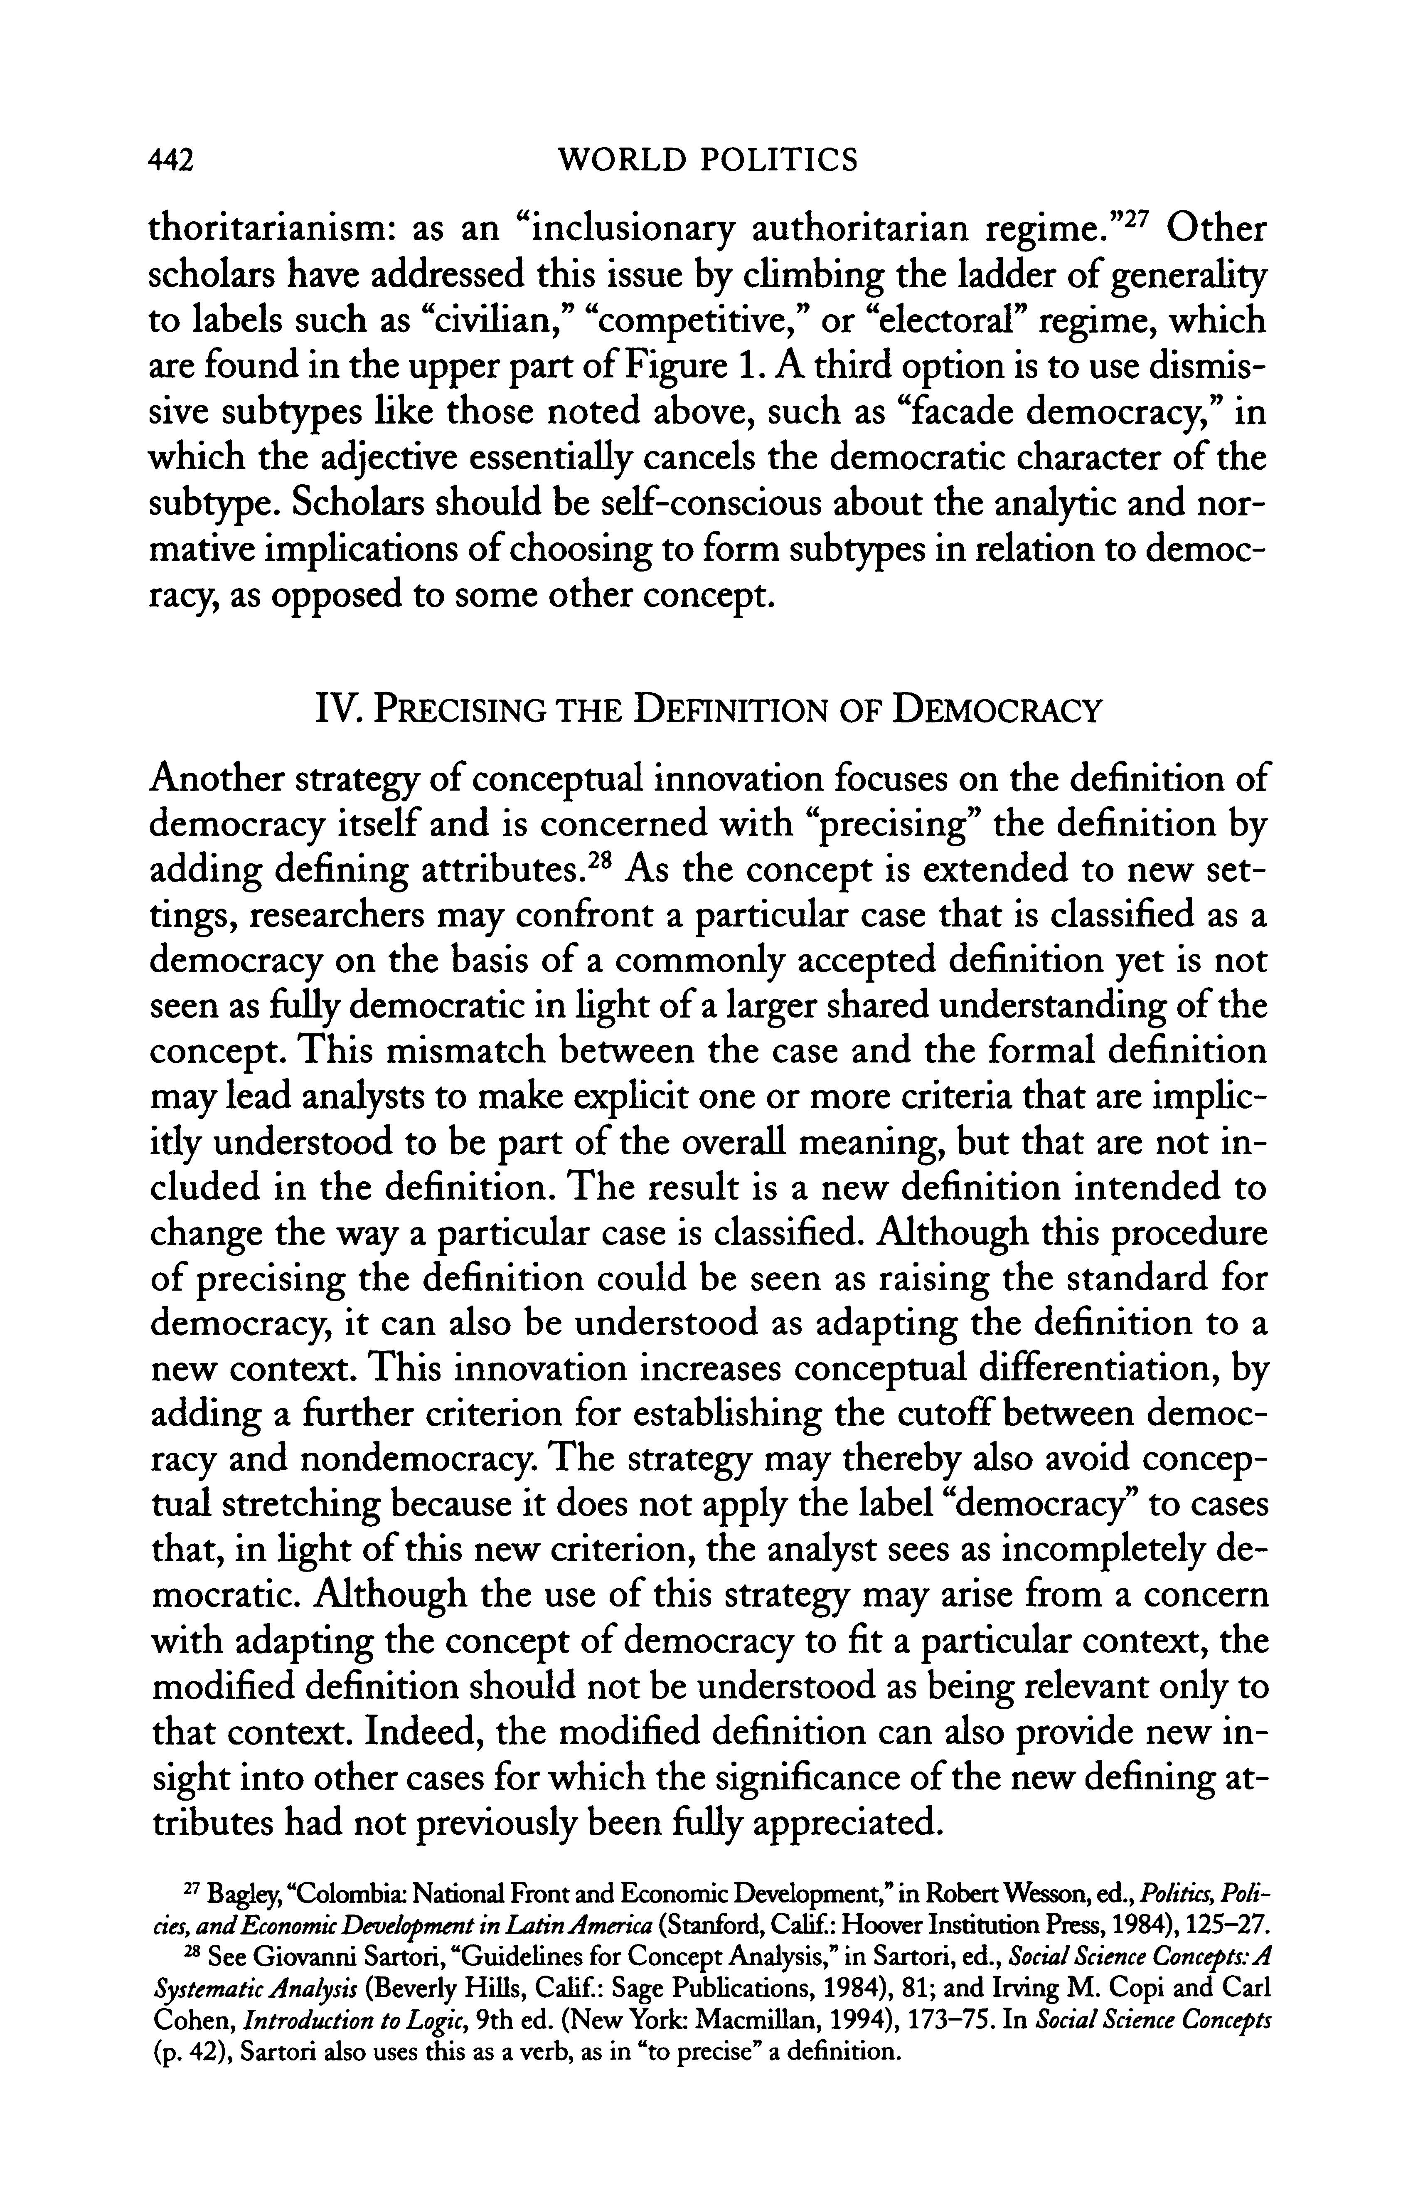
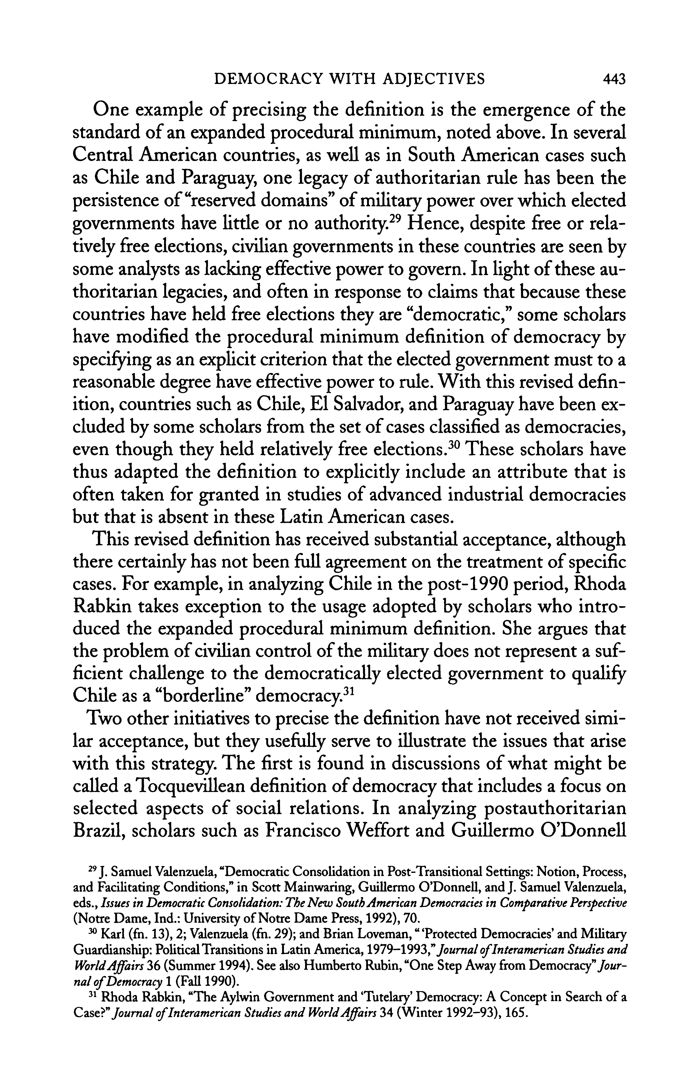
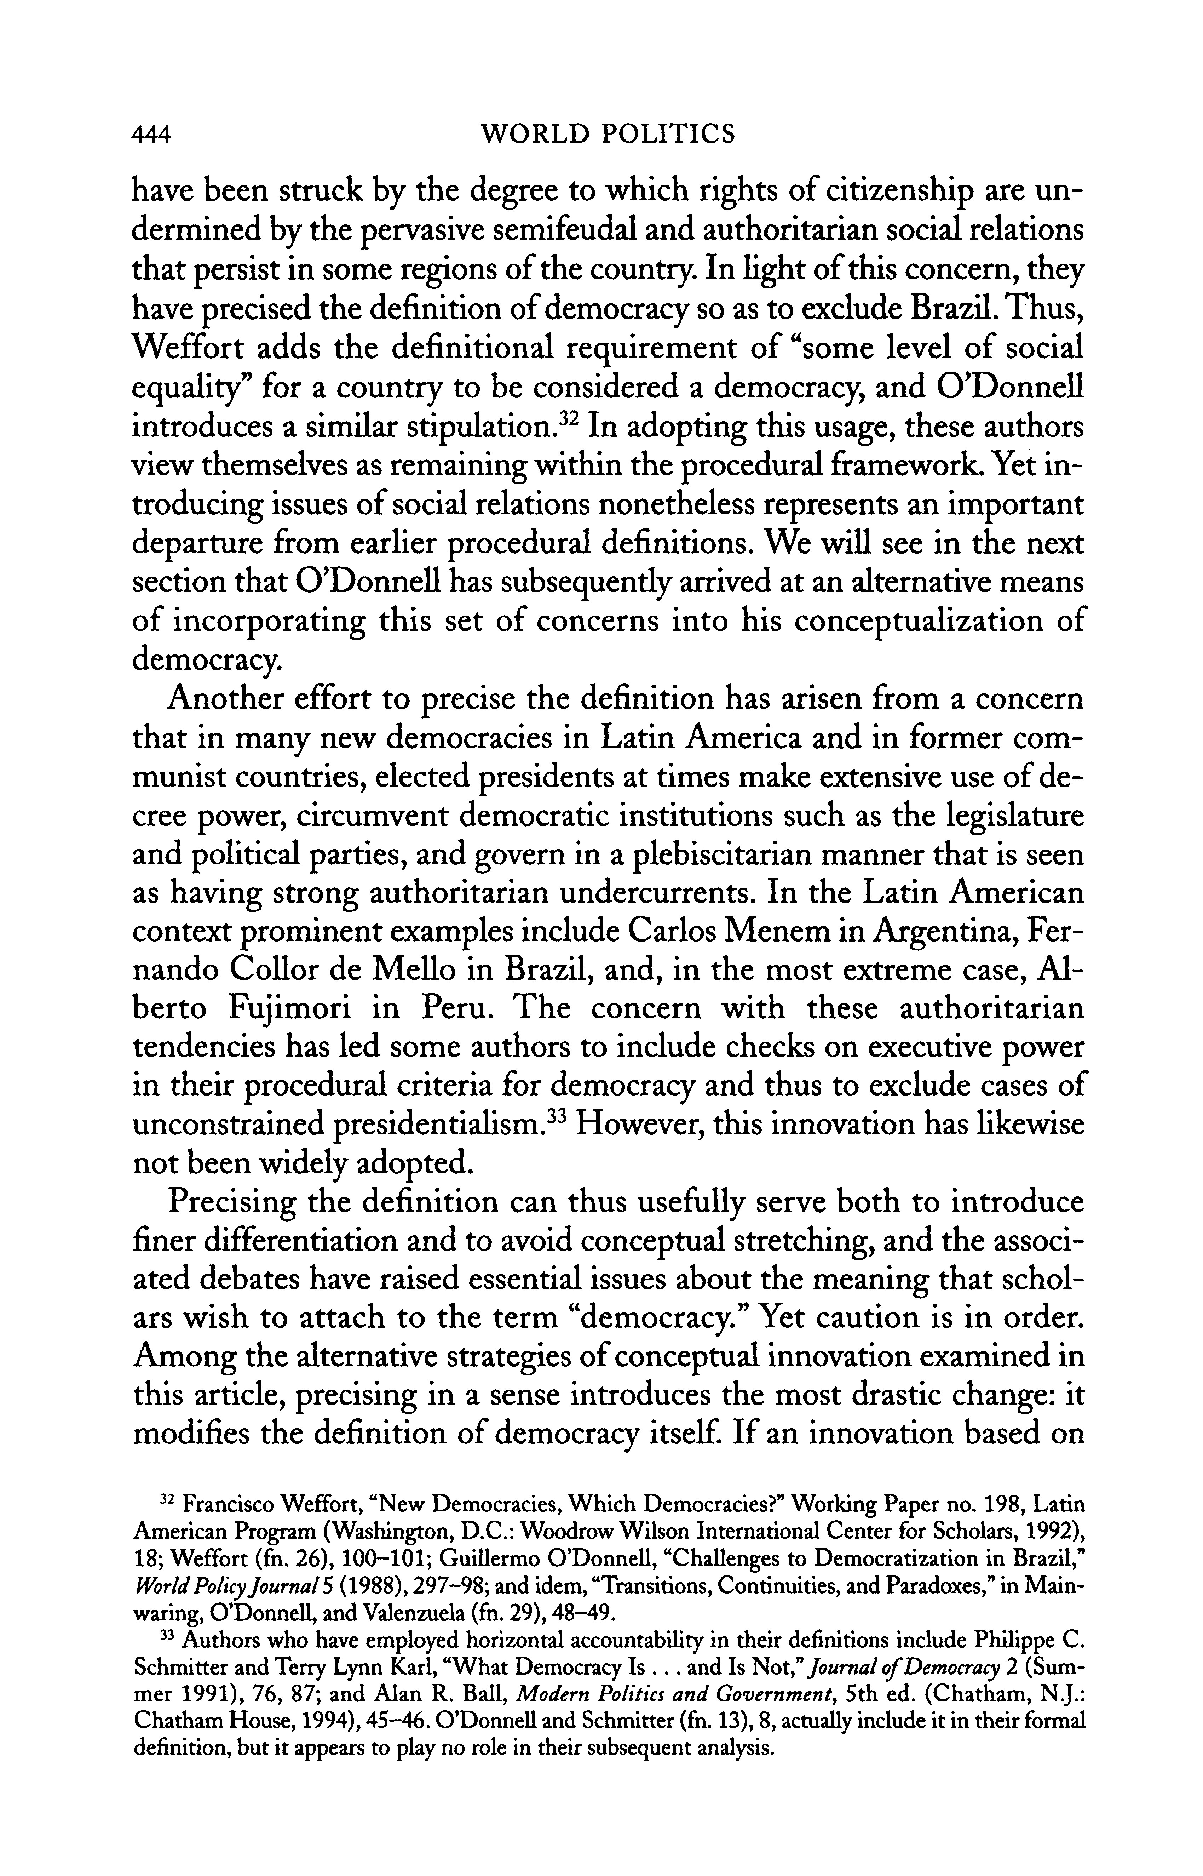
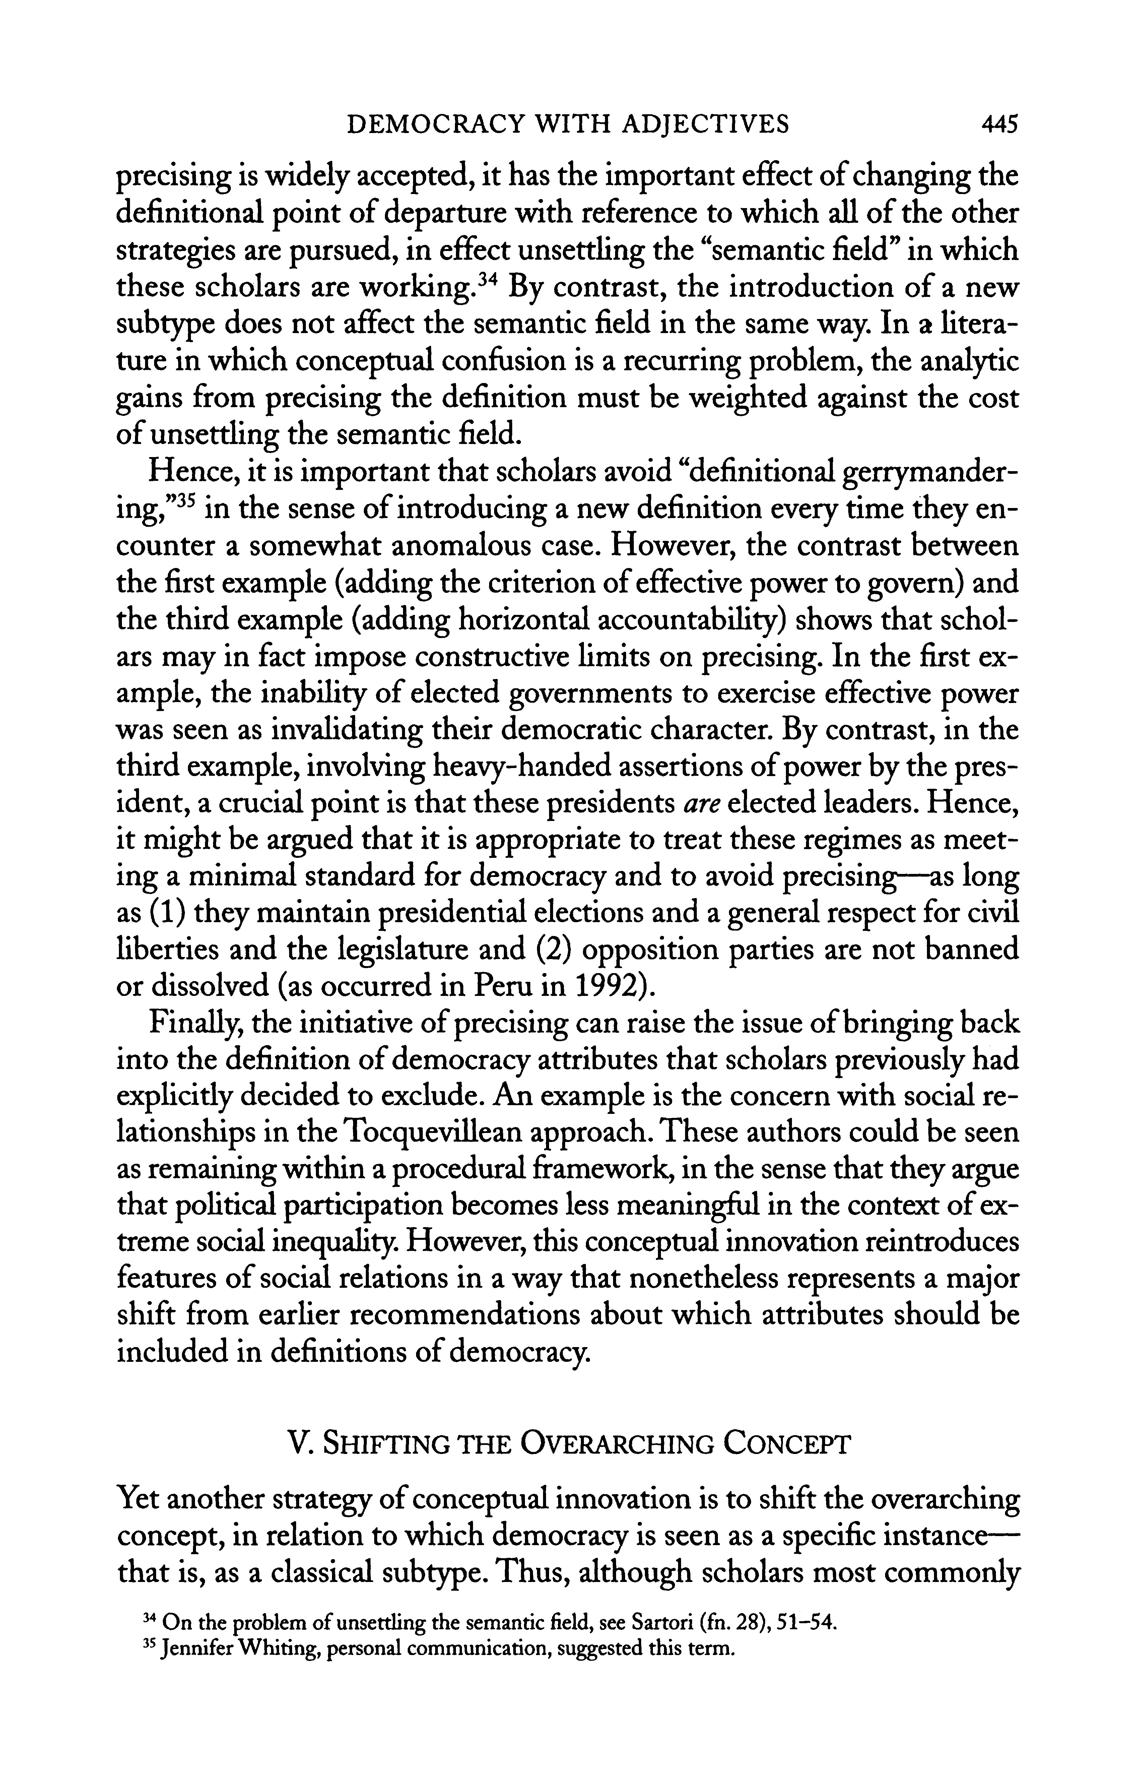
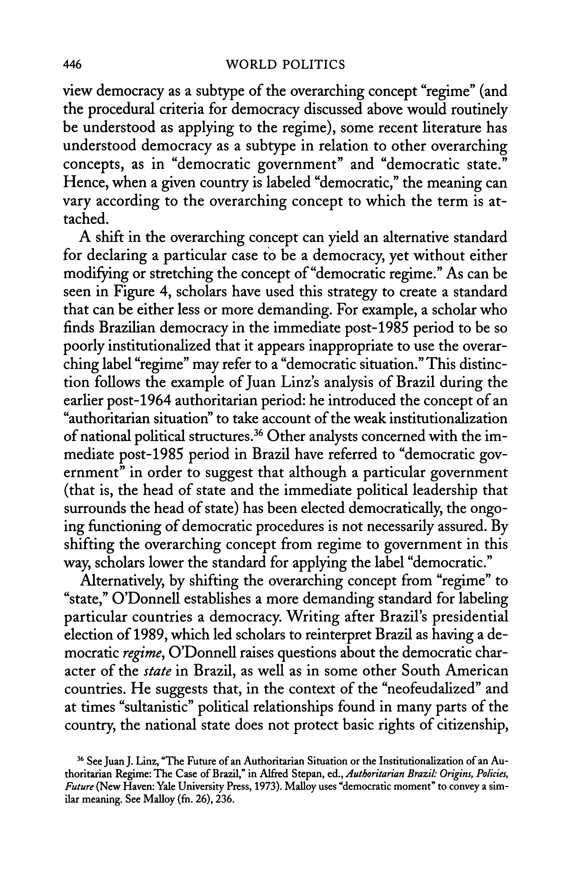
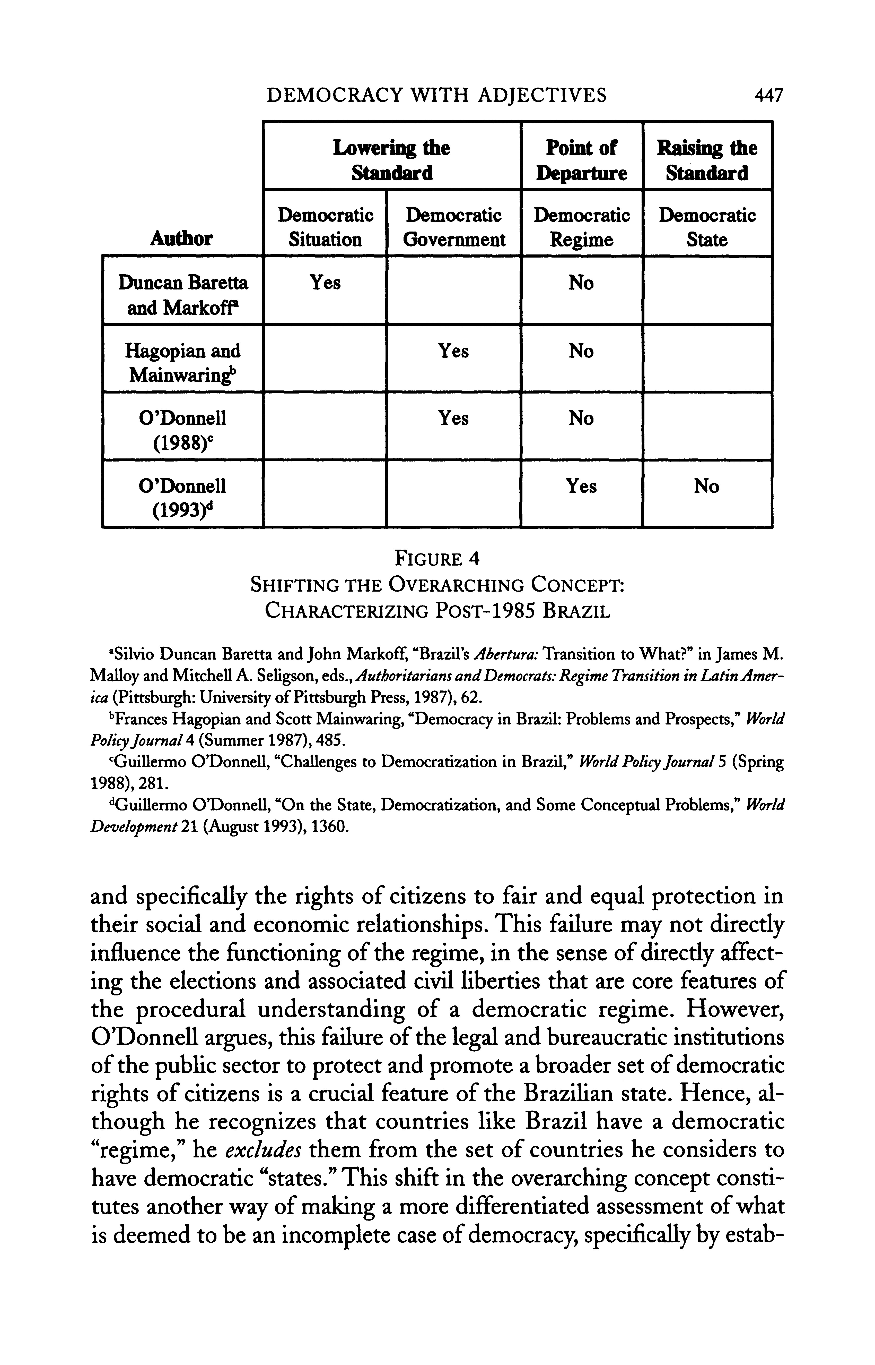
447
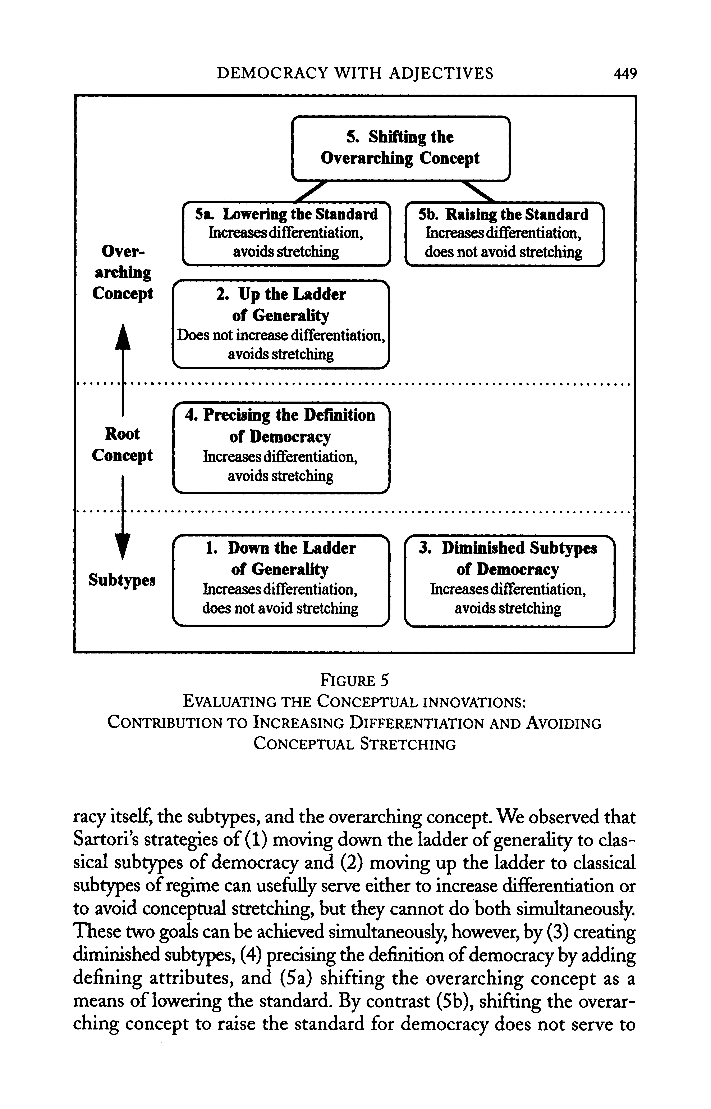

449

:___:

?

